**Mono-ha**

‘Mono-ha’ refers to a unique art movement, its artists active in Japan most visibly from 1968 to 1975. Translating as the ‘school of things’, these artists brought ‘things’ (*mono*) – earth, wood, metal, glass, cotton, stone, paper and the like – together, usually with minimal artistic intervention and in an essentially unaltered state. Following a reductive logic, ‘arrangement’ was integral to Mono-ha activity, positing the artist as a kind of coordinator attempting to bring about new perceptions of matter, materials, and the spatial relationships between them. Centred around approximately ten young artists, whose outcomes were frequently sculptural and site-specific, the emergence of Mono-ha is usually taken as coinciding with the creation of *Phase – Mother Earth* by Tama Art University or ‘*Tamabi*’ graduate Nobuo Sekine (b.1942–) ([www.nobuosekine.com](http://www.nobuosekine.com)) in Suma Rikyu Park, Kobe, as part of the 1st Open Air Contemporary Sculpture Exhibition in October, 1968. It comprised a cylindrically-shaped hole dug in the ground, 2.2 metres wide and 2.7 metres deep, beside which stood a tower of the hole’s excavated earth, compacted into the same cylindrical shape and mirroring the void from where it came. Later recalling it, Sekine remarked on being mesmerised by the sheer physicality of what stood before him upon its completion.

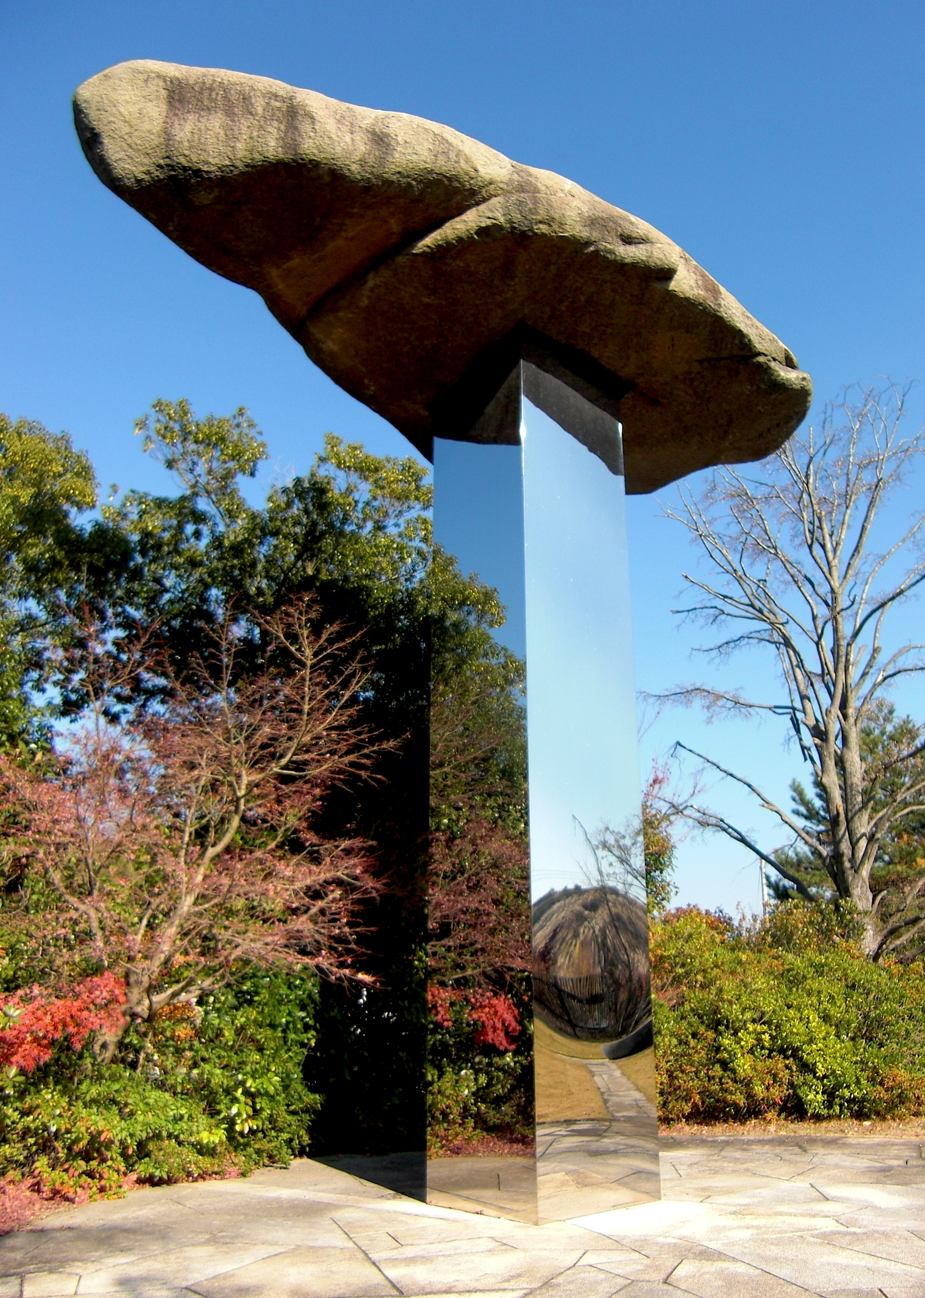

Nobuo Sekine, *Phase in the Sky (空相)*,stone, polished metal, 2004. Tama Art University, Tokyo. Photo: Neilton Clarke

Prior to that exhibition, Sekine shared a Yokohama warehouse space with then *Tamabi* students Susumu Koshimizu (b.1944–) and Katsurō Yoshida (b.1943–) while the university was on lockdown during the late-1960s period of nation-wide student activism. Later that year Sekine met Korean-born artist Ufan Lee (b.1936–) ([www.studioleeufan.org](http://www.studioleeufan.org)), who moving to Japan in 1956 had studied philosophy at Nihon University. They and other *Tamabi*-schooled artists Kishio Suga (b.1944–) and Katsuhiko Narita (1944–1992) assisted in the formation of Mono-ha by beginning regular meetings at ‘Top’, a cafe in Tokyo’s Nishi-Shinjuku, where their discussions reportedly focused on ways to transcend Western Modernism among other topics. With his background in philosophy and aesthetics, Lee would become the group’s elder statesman and spokesperson. Other artists forming the circle included Tokyo National University of Fine Arts & Music graduates Kōji Enokura (1942–1995) and Noburu Takayama (b.1944–), and Nihon University graduate Noriyuki Haraguchi (b.1946–). The idiosyncratic tendencies and stylistic variety among these artists was underpinned by a shared minimalism and the poignant simplicity of their artistic solutions.

**References and further reading**

Blum and Poe Gallery, Los Angeles – represents various Mono-ha artists; held the exhibition *Requiem for the Sun: The Art of Mono-ha*, 2012:

[www.blumandpoe.com](http://www.blumandpoe.com)

Kamakura Gallery, Japan with section devoted to Mono-ha:

[www.kamakura-g.com/new_index/home-e.htm](http://www.kamakura-g.com/new_index/home-e.htm)

Tokyo Art Beat (TAB) online publication, with *An Introduction to ‘Mono-ha’* posting by Ashley Rawlings (2007):

<http://www.tokyoartbeat.com/tablog/entries.en/2007/09/an-introduction-to-mono-ha.html>

YOSHITAKA, Mika; JACK, James; DOTAN, Oshrat (2012) *Requiem for the Sun: The Art of Mono-ha* (exhibition catalogue), Los Angeles: Blum & Poe (ISBN: 9780966350326)

MUNROE, Alexandra; TATEHATA, Akira; YOSHITAKE, Mika (2012) *Lee Ufan: Marking Infinity* (catalogue to the 2011 exhibition). New York: Guggenheim Museum Publications (ISBN: 9780892074181)

NAKAI, Yasuyuki; MINEMURA, Toshiaki (2005) *Reconsidering Mono-ha* (exhibition catalogue). Osaka: The National Museum of Art, Osaka, 2005.

<http://www.nmao.go.jp/en/exhibition/2005/id_1025055227.html>

LEE, Ufan (2004) *Lee Ufan: The Art of Encounter*

London: Turner/Lisson Gallery (ISBN: 978097830311)

GROOM, Simon; LEE, Ufan; TATEHATA, Akira (2001) *Mono-ha – School of Things* (catalogue for the 2001 exhibition). Cambridge: Kettle’s Yard Gallery (ISBN: 0907074871)

**TO: ROUTLEDGE (REM) EDITORIAL & DESIGN**

**FROM: NEILTON CLARKE (Tokyo)**

**Email: neil@unswalumni.com**

**RE: PERMISSION TO USE PHOTO, MONO-HA ENTRY**

Dear REM Staff,

This is to grant use of the following artwork photo taken by me for

the REM Mono-ha entry and pasted into the prepared word

document:

Nobuo Sekine, *Phase in the Sky (*􀛭􀫬*)*, stone, polished metal,

2004. Tama Art University, Tokyo. Photo Neilton Clarke

The location of this artwork, the campus of Tama Art University,

Tokyo allows it accessible viewing (particularly for students and

staff) and lends it an ongoing currency.

If for some reason an alternative image was required, the images

below would suit, showing artworks by Susumu Koshimizu and

Kishio Suga. They would need clearance by the

Blum and Poe (Gallery), Los Angeles (www.blumandpoe.com),

which represents those Mono-ha artists. Its director of publications

is Ms Lynda Bunting (lynda@blumandpoe.com).

Yours sincerely,

Neil Clarke

Neilton Clarke

1056 Itsukaichi,

Akiruno-shi,

Tokyo, JAPAN 190-0164

neil@unswalumni.com

Tel: 81-42-595.2987

１９０−０１６４

東京都あきる野市五日市１０５６

J

A

P

A

N